

Flexible Iris Retractors
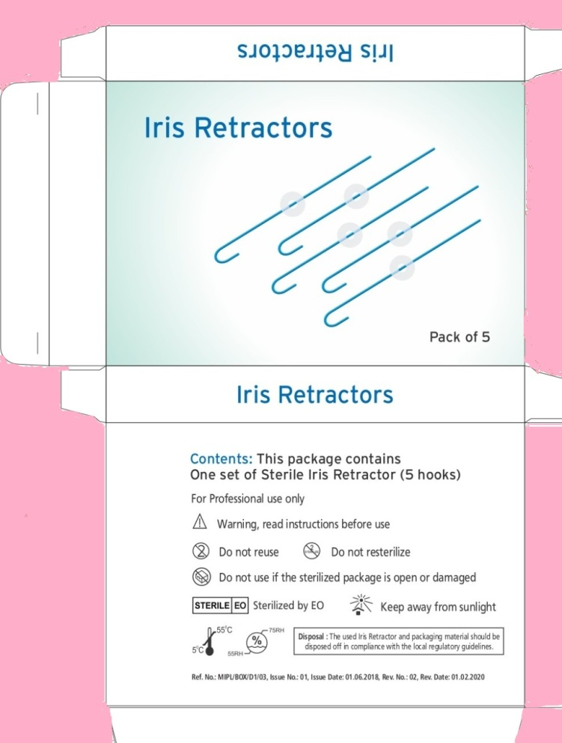 | 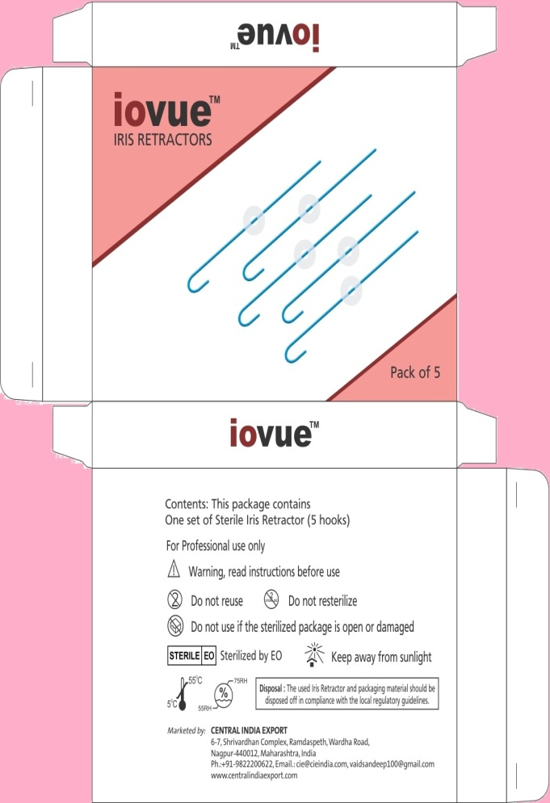
- Iris retractors are used for temporary retraction (pupil enlargement) of the iris where dilation cannot be achieved pharmacologically.
- Flexible retractors made of bright blue PP (Polypropylene)
- Stretches and stabilizes the Iris during the cataract surgery
- An adjustable silicon stopper provides a superior grip and allows adjustment of the pupil size
- Easy to insert and remove


